Delta Architectural Framework Catalogues
This pattern creates a number of Packages for each of the types of DAF. They are organised in the four domains of architecture
- Business
- Data
- Application
- Technology
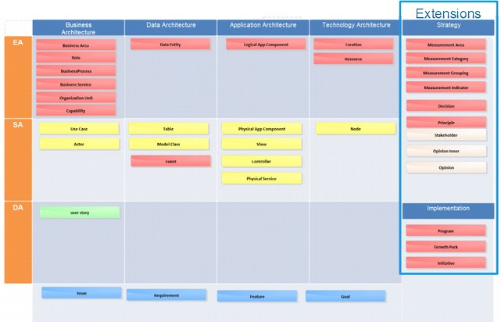

Discussion
The pattern can be used within the Architectural Landscape or as a part of a project’s structure.
Reference
- TOGAF

